**Assignment Week 1 Java Overview**

Program 1: Write a Java program to find the common elements between two arrays (String values)

import java.util.Scanner;

import java.util.HashSet;

import java.util.List;

import java.util.ArrayList;

import java.util.Arrays;

public class _01_CommonElementsInArrays {

    public static void main(String[] args) {

        Scanner scanner = new Scanner(System.in);

        System.out.println("Enter the size of the array1");

        int arr1Len = scanner.nextInt();

        System.out.println("Enter the size of the array2");

        int arr2Len = scanner.nextInt();

        System.out.println("Enter the elements of the array1");

        String arr1[] = new String[arr1Len];

        for (int i = 0; i < arr1Len; i++) {

            arr1[i] = scanner.next();

        }

        System.out.println("Enter the elements of the array2");

        String arr2[] = new String[arr2Len];

        for (int i = 0; i < arr2Len; i++) {

            arr2[i] = scanner.next();

        }

        scanner.close();

        System.out.println("Common elements of array1 and array2: " + findCommonElements(arr1, arr2));

    }

    private static List<String> findCommonElements(String[] array1, String[] array2) {

        HashSet<String> arr1 = new HashSet<>(Arrays.asList(array1));

        List<String> commonElements = new ArrayList<>();

        int arr2Len = array2.length;

        for (int i = 0; i < arr2Len; i++) {

            if (arr1.contains(array2[i])) {

                commonElements.add(array2[i]);

            }

        }

        return commonElements;

    }

}

Output:

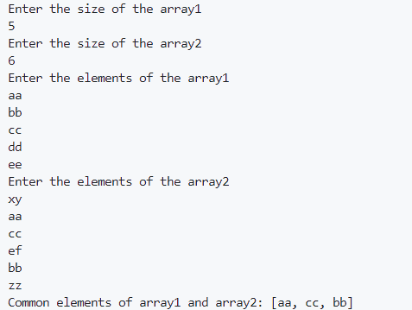

Program 2: Find second largest element in an array

import java.util.Arrays;

import java.util.Scanner;

public class _02_SecondLargestElement {

    public static void main(String[] args) {

        int arraySize, array[];

        Scanner scanner = new Scanner(System.in);

        System.out.println("Enter array size: ");

        arraySize = scanner.nextInt();

        array = new int[arraySize];

        System.out.println("Enter array elements: ");

        for (int i = 0; i < arraySize; i++) {

            array[i] = scanner.nextInt();

        }

        scanner.close();

        int secondLargestElement = findSecondLargestElement(array);

        if (secondLargestElement != Integer.MIN_VALUE) {

            System.out.println("Second largest element in " + Arrays.toString(array) + " is: " + secondLargestElement);

        } else {

            System.out.println("Array does not have enough elements to find second largest.");

        }

    }

    private static int findSecondLargestElement(int[] array) {

        int firstLargest = Integer.MIN_VALUE;

        int secondLargest = Integer.MIN_VALUE;

        for (int element : array) {

            if (element > firstLargest) {

                secondLargest = firstLargest;

                firstLargest = element;

            } else if (element > secondLargest && element != firstLargest) {

                secondLargest = element;

            }

        }

        return secondLargest;

    }

}

Output:

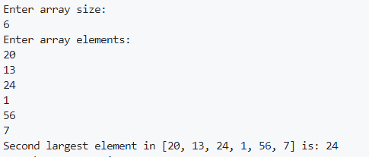

Program 3: Write a program to print all subarrays with 0 sum

import java.util.ArrayList;

import java.util.Arrays;

import java.util.HashMap;

import java.util.Scanner;

public class _03_SubarraysWithZeroSum {

    public static void main(String[] args) {

        int arraySize, array[];

        Scanner scanner = new Scanner(System.in);

        System.out.println("Enter array size: ");

        arraySize = scanner.nextInt();

        array = new int[arraySize];

        System.out.println("Enter array elements: ");

        for (int i = 0; i < arraySize; i++) {

            array[i] = scanner.nextInt();

        }

        scanner.close();

        findSubarraysWithZeroSum(array);

    }

    private static void findSubarraysWithZeroSum(int[] array) {

        HashMap<Integer, ArrayList<Integer>> sumMap = new HashMap<>();

        int sum = 0;

        for (int i = 0; i < array.length; i++) {

            sum += array[i];

            if (sum == 0) {

                System.out.println("Subarrays with 0 sum: " + Arrays.toString(Arrays.copyOfRange(array, 0, i + 1)));

            }

            ArrayList<Integer> sumIndexList = sumMap.getOrDefault(sum, new ArrayList<>());

            if (sumMap.containsKey(sum)) {

                int sumIndexListSize = sumIndexList.size();

                for (int j = 0; j < sumIndexListSize; j++) {

                    int prevIndex = sumIndexList.get(j);

                    System.out.println("Subarrays with 0 sum: " + Arrays.toString(Arrays.copyOfRange(array, prevIndex+1, i + 1)));

                }

            }

            sumIndexList.add(i);

            sumMap.put(sum, sumIndexList);

        }

    }

}

Output:

